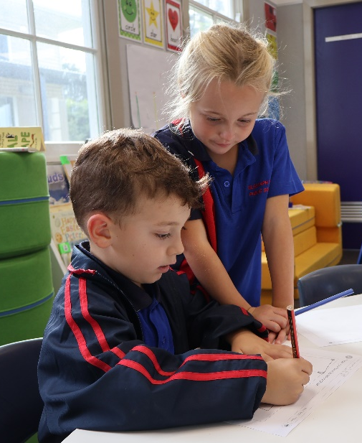
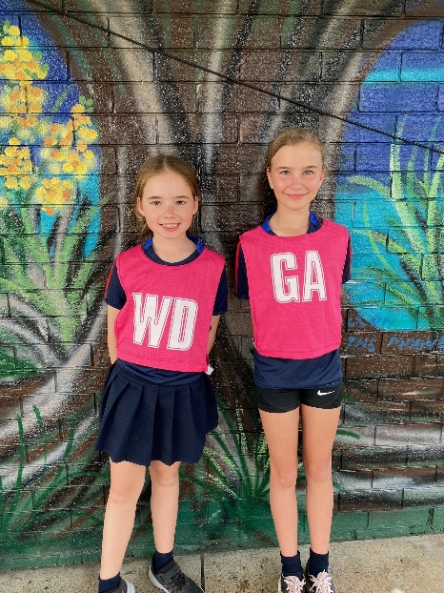 | 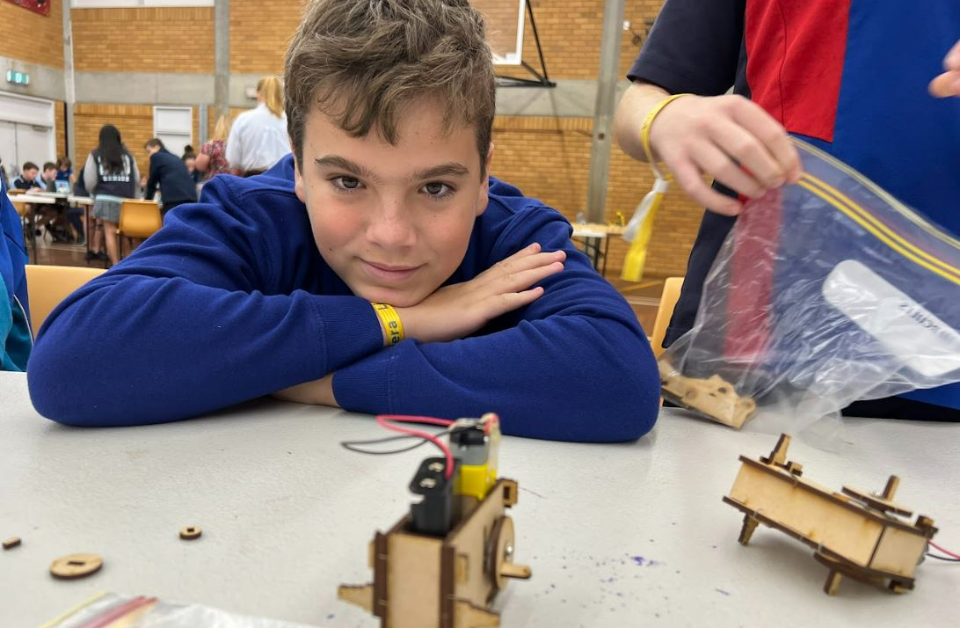
Telegraph Point Public School
Student Engagement & Wellbeing Policy
Published | July 2023
Review | June 2025

Rationale
Connect
Aboriginal education | Page 4
Anti-bullying | Page 4
Anti-racism | Page 8
Attendance | Page 9
Homework | Page 25
Multicultural education | Page 25
School uniforms | Page 25
Student participation and leadership | Page 26
Succeed
Out-of-home care | Page 29
Personalised learning support plan / Individual education plan | Page 31
Positive behaviour for learning (PBL) | Page 36
Protecting and supporting children and young people (child protection) | Page 41
Student behaviour and discipline | Page 44
Supporting EAL/D students | Page 49
Supporting refugee students | Page 49
Supporting students with disability | Page 50
Thrive
Drug education | Page 50
Learning support team | Page 51
Nutrition | Page 53
Road safety education | Page 53
Student health | Page 54
Sun safety | Page 56
Transition to Kindergarten | Page 57
Transition to high school | Page 57
Student use of digital devices and online services | Page 59

Rationale
The Telegraph Point Public School Student Engagement & Wellbeing Policy is organised according to the Department of Education (DoE) Wellbeing Framework for Schools. We are committed to supporting students to connect, succeed and thrive at each stage of their development and learning. Local decision making, along with a planned and systematic focus on the quality teaching, learning and engagement of student wellbeing should ensure the holistic development and future success of our students.
Wellbeing Framework for Schools
The Wellbeing Framework equips schools and their communities to support students at each stage of their development and to do this through quality teaching, learning and engagement.
Schools will achieve this through planning and decision-making at the local level to meet the needs of their students. This work is underpinned by high standards, clear expectations, counselling and wellbeing resources.
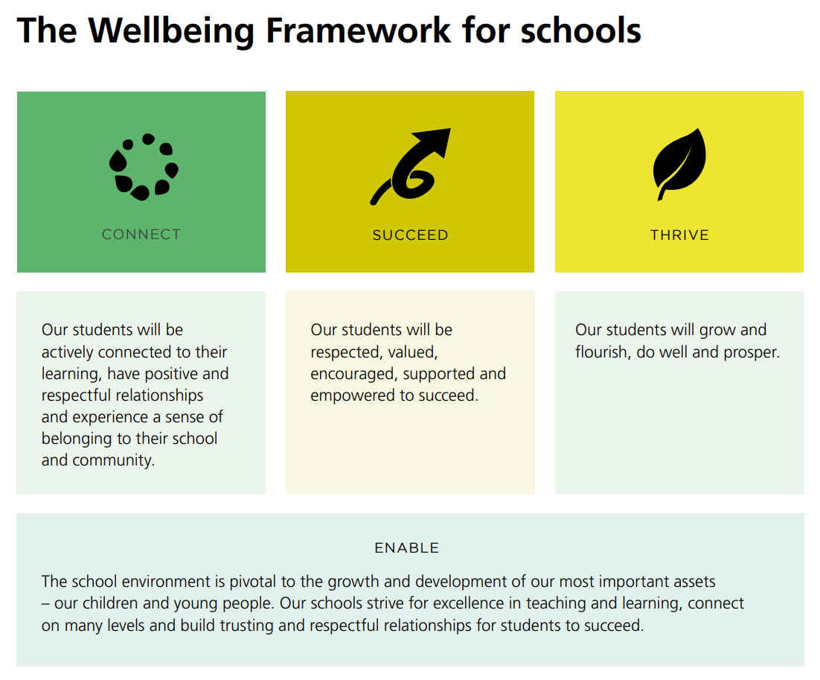
Strengths-based approach
The Wellbeing Framework for Schools enables schools to build on the individual strengths of students and positions them to succeed and thrive throughout life. The framework complements a range of education reforms across NSW public schools.
NSW Department of Education policies and resources:
- Wellbeing Framework for Schools
- Behaviour Code for Students
- National Safe Schools Framework
- Supported Students, Successful Students
- Australian Student Wellbeing Framework

Aboriginal Education
Telegraph Point Public School is committed to improving the educational outcomes and wellbeing of Aboriginal and Torres Strait Islander students so that they excel and achieve in every aspect of their education.
We pride ourselves on increasing knowledge and understanding of the histories, cultures and experiences of Aboriginal and Torres Strait Islander people as the First Peoples of Australia. The strength, diversity, ownership and richness of Aboriginal cultures and Custodianship of Country are respected, valued and promoted.
Telegraph Point Public School acknowledges the inherent right of Aboriginal students to fair, equitable, culturally inclusive and significant educational opportunities so that all students obtain a high-quality education as a platform for enriching their life chances and achieving their full potential.
In honouring the Together We Are, Together We Can, Together We Will - Maintaining a Collaborative Partnership into the Future partnership agreement, Telegraph Point Public School collaborate with the NSW AECG Inc. in the monitoring and evaluation of strategies and will report on progress in implementing this policy against outcomes and targets for Aboriginal education.
NSW Department of Education policies and resources:
- Aboriginal Education Policy
- National Aboriginal and Torres Strait Islander Education Strategy
- Together We Are, Together We Can, Together We Will

Anti-bullying
This plan outlines the processes for preventing and responding to student bullying in our school and reflects the Bullying: Preventing and Responding to Student Bullying in Schools Policy of the New South Wales Department of Education.
The Telegraph Point Public School community has been involved in the development of this plan. The school values this input and will engage the community further through the implementation of this plan and Positive Behaviour for Learning (PBL).
The NSW anti-bullying website supports school staff, parents and carers, volunteers and contracted staff, and students to discourage, prevent, identify, and respond effectively to student bullying behaviour, where it does occur. Further information can be accessed at their website https://antibullying.nsw.gov.au/

What is bullying?
Bullying is repeated verbal, physical, social or psychological behaviour that is harmful and involves the misuse of power by an individual or group towards one or more persons. Cyberbullying refers to bullying through information and communication technologies.
Bullying can involve humiliation, domination, intimidation, victimisation and all forms of harassment including that based on sex, race, disability, homosexuality or transgender. Bullying in any form or for any reason can have long term effects on those involved, including bystanders.
Conflicts or fights between equals or single incidents are not defined as bullying.
Types of bullying
Bullying takes on many forms and can include any combination of the following:
- Verbal: rude remarks, teasing, put downs, insults, name calling, threats or abusive phone calls
- Physical: hitting, pushing, punching, tripping, scratching, spitting, kicking or property damage
- Social: exclusion, alienating, making inappropriate gestures
- Psychological: spreading rumours intentionally, making degrading comments about another’s culture or social background, hiding or damaging possessions, sending malicious SMS, email messages and inappropriate content via social media, including shared images.
Responsibilities
Everyone has a shared responsibility to reduce aggression in our society.
- No-one likes it
- No-one deserves it
- No-one needs it
- So always report it
Telegraph Point Public School promotes PBL and encourages respectful relationships among all members of the school community.
Schools exist in a society where incidents of bullying behaviour may occur. Preventing and responding to bullying behaviour in learning and working environments is a shared responsibility of all departmental staff, students, parents, caregivers and members of the wider community.
School staff:
- respect and support all students in all aspects of their learning
- model and promote appropriate behaviour
- respond in an appropriate and timely manner to incidents of misbehaviour and/or bullying according to the school Anti-Bullying Plan
- embed anti-bullying strategies as part of the curriculum
Students:
- behave appropriately, respecting individual differences and diversity
- behave as responsible digital citizens
- follow the school Anti-Bullying Plan, including PBL
- behave as responsible bystanders
- report incidents of bullying according to the Telegraph Point Public School Anti-Bullying Plan
Parents and caregivers:
- support their children to become responsible citizens and to develop responsible online behaviour
- be aware of the school Anti-Bullying Plan and help their children understand bullying behaviour
- support their children to develop positive strategies to respond to bullying through the Anti-Bullying Plan
- report incidents of school related bullying to the school and encourage students to do the same
- work collaboratively with the school to resolve incidents of bullying should they occur
Community members:
- model and promote positive relationships that respect and accept individual differences
- and diversity within the school community
- support the school’s Anti-Bullying Plan through words and actions
- work collaboratively with the school to resolve incidents of bullying when they occur
Protection
The school understands that bullying can come in many forms, including cyberbullying. Regardless of what form it takes, bullying can have a detrimental impact on the wellbeing of students. It is important that the school and its community has a clear understanding as to what constitutes bullying, as it is different to students experiencing conflict, social difficulties, or simply not getting on.
The commitment to reducing incidents of bullying is a responsibility shared by the entire school community. The positive relationship Telegraph Point Public School has with its parent community and staff is vital in ensuring the safety and happiness of its students.

Prevention
Telegraph Point Public School has a number of strategies and programs to take all reasonable steps to prevent bullying. Throughout the year, as part of the PDHPE program, students complete activities to build resilience and develop students’ strategies to identify and respond appropriately to bullying-type behaviours.
Telegraph Point Public School’s expectations in line with the implementation of the PBL initiative promotes positive behaviour for learning within the school and valuing each student. PBL data is regularly monitored to determine any trends of student behaviour that may indicate bullying. This will then be addressed in any number of ways, including a referral to Learning and Support Team (LaST), communication with parents, implementation of targeted action or intervention for the student demonstrating bullying behaviours and/or the victim of these behaviours.
Our Police Youth Liaison Officer comes to the school annually and speaks with students from Stages 2 & 3 about cyberbullying and appropriate actions to take in the event students witness or experience cyberbullying.
Telegraph Point Public School will regularly communicate with the school community to promote positive behaviour and anti-bullying messages, including PBL strategies and information about the NSW anti-bullying website.
Early Intervention
Parents and students are advised to speak to the classroom teacher in the first instance if they have experienced any bullying behaviour.
If a student is identified as being at risk of developing long term difficulties with social relationships, or have been identified as having previously experienced bullying or engaged in bullying behaviour, that child may be referred to the school’s Learning and Support Team (LaST). A range of strategies, from behavioural/cognitive assessment, individual behaviour plans or referral to outside agencies may be recommended.
Response
Students, including bystanders, are encouraged to report any inappropriate behaviour including bullying immediately to the teacher on duty or classroom teacher. The teacher will then manage the behaviour under the guidelines of PBL. If it is deemed bullying-type behaviour, a member of the School Executive will be informed through the PBL referral forms. Parents will be contacted if there is a repetition of such behaviour.
Parents are encouraged to report any incidences of bullying that their child has been involved in or has witnessed to the school. This will be followed up by a member of the School Executive who will speak with all students involved and provide the parent with timely feedback.
Students who have been involved in multiple bullying incidents will be referred to the LaST. Other interventions, depending on each individual case, may also involve referral to the Anti-Racism Contact Officer (ARCO), referral to department and/or outside agencies, the Child Well Being Unit, behaviour guidance programs, time out from the class or playground, and in extreme cases, suspension.
Students who have witnessed bullying may also require support, such as counselling, and this will be done on an individual needs basis. Incidents such as assaults or threats which far exceed the school’s PBL structure will be reported to the police by the Principal.
Parents who are dissatisfied with the school’s response may choose to make a complaint to the Department of Education. The Department’s Complaints Handling Policy can be found on their website education.nsw.gov.au
NSW Department of Education policies and resources:
- Bullying of Students: Prevention and Response Policy
- NSW Anti-Bullying website
- Bullying, No Way!
- eSafety Commissioner

Anti-racism
Telegraph Point Public School rejects all forms of racism. It is committed to the elimination of racial discrimination – including direct and indirect racism, racial vilification and harassment – in all aspects of the learning and working environment.
No student, employee, parent, caregiver or community member should experience racism within the learning or working environment of Telegraph Point Public School. Eradicating expressions of racism in learning and working environments, and challenging the attitudes that allow them to emerge, is the shared responsibility of Telegraph Point Public School staff.
All teaching and non-teaching staff of Telegraph Point Public School contribute to the eradication of racism by promoting acceptance of Australia's cultural, linguistic and religious diversity, challenging prejudiced attitudes and ensuring that sanctions are applied against racist and discriminatory behaviours.
Telegraph Point Public School has a trained Anti-Racism Contact Officer (ARCO) who provides timely and professional responses to complaints regarding racism.
Members of the school community can make a complaint about racism, including students, parents, staff members and members of the school’s wider community. Complaints of racism within the school community should be directed to the school’s Anti-Racism Contact Officer (ARCO).
The Principal is responsible for ensuring that the Anti-Racism Policy is implemented in school. Complaints regarding racism are dealt with in accordance to the Complaints Handling Policy.
This policy applies to all staff employed in NSW Public Schools including NSW government schools and corporate offices. It also applies to students who attend government schools and has implications for each school community.
The NSW Anti-Discrimination Act (1977) along with the Commonwealth Racial Discrimination Act (1975) make racial discrimination and vilification illegal in New South Wales. These Acts provide the legislative context and foundation for the Anti-Racism Policy of the Department of Education.
NSW Department of Education policies and resources:
- Aboriginal Education Policy
- Anti-Racism policy
- Complaints Handling Policy
- Multicultural Education Policy
- Opening the School Gate: Engaging Migrant and Refugee Families
- Strengthening Community Harmony: Advice and Resources for Schools
- Racism, No Way!

Attendance
All schools in New South Wales are committed to providing safe and supportive learning environments for all students which address their education needs. In NSW all children between the ages of six and below the minimum school leaving age of seventeen are legally required to attend school or approved education facility.
Regular attendance at school is essential if students are to maximise their academic and social potential. Schools, in partnership with parents, are responsible for promoting the regular attendance of students. Parents are legally responsible for the regular attendance of their children and school staff are responsible for the monitoring or part or whole day absences.
The Telegraph Point Public School Attendance Practices and Procedures document aims to provide teachers, parents and community members with an understanding of the school process to ensure that every student has the opportunity to attend school regularly.
Benefits of regular attendance
Regular attendance has benefits for students, teachers, parents/caregivers and the community.
These benefits include:
For the students
- Maximising learning opportunities which will optimise life choices
- Assisting to develop skills and attitudes that will help the students be successful later in life, such as; punctuality, organisation and confidence
- Success in learning outcomes
- Making friends and learning to maintain relationships
- Learning social skills to interact with others
For teachers:
- Improved learning outcomes for all
- Ability to fulfil responsibilities to all students
- Maintaining relationships with students, which may reduce disruptions to learning due to poor student behaviour
- Saving resources and time by avoiding non-attendance follow up procedures
For parents/caregivers:
- Children are safer at school than being unsupervised at home or in the community
- Children can succeed in their learning
- Children are more likely to complete Year 12 and have broader opportunities and high educational goals
- Fewer incidents of negative contact with government agencies
For the community:
- Increased level of safety for all
- Young people are less likely to be involved in criminal behaviour
- The community as a whole will experience less cost, both financially and socially.
Responsibilities
Regular attendance at school is the responsibility of students, parents and school staff.
Student responsibilities:
- Arrive punctually between 8:25 – 8:55am
- Attend school every day between 8:55am and 2:55pm.
- Attend school each day when instruction is offered unless the school receives a justified reason for being absence (e.g. sickness)
- Provide handwritten letters or notes from parents to the classroom teacher or front office promptly
- When arriving late, students are required to present at the office, before going to class with a late slip
- If late, come to class quietly so other students’ learning is not disturbed
Parent responsibilities:
- Actively encourage their children to regularly attend school
- Notify the school of any absences in writing or via telephone within 7 days from the date of absence
- Provide the office with an appropriate, justifiable explanation for arriving late or leaving early
- Seek medical attention in the case of illness or injury
- Inform the school if an extended absence is likely
- Inform the school of any changes to their contact details
- Ensure children are picked up promptly from the school at the end of the school day at 2:55pm.
- Contact the school if delayed for any reason or length of time when picking up children
- Apply for extended leave via the school principal of withdrawing their child for more than 5 consecutive school days.
Teacher responsibility:
- Actively encourage students to attend school regularly by providing an engaging education program which is inclusive of the needs of all the learners
- Monitor each child’s attendance and implement the school’s attendance procedures by following the Attendance Procedures Flowchart
- Implement strategies aimed at increasing school attendance, as outlined in the Attendance Procedures Flowchart
- Accurately complete the attendance register on Sentral each day (which is transferred to EBS weekly).
- Complete a paper roll for partial absences for the class when attending approved school activities, such as excursions and sporting events. Provide a copy of this roll to administrative staff
- Remind students to supply a note or explanation when returning to school
- Distribute unexplained absence notes to students, which are provided by administrative staff weekly
- Coordinate a collection of work for students who are unable to attend school for acceptable reasons, when requested by parents/carers.
- Add student name to their class program after a student is absent for two consecutive days
- Inform the school principal of any concerns about attendance, including a complete intervention checklist, as outlined in the Attendance Procedures Flow-Chart
- Complete students’ interview (NIPs) and inform the Principal so parents can be informed.
Attendance Coordinator
- Analyse attendance data and identify students with an attendance concern
- Take action when attendance concerns are raised by class teachers, as detailed in the Attendance Procedures Flow-Chart
- Complete letter to parents to notify when a non-attender interview (NIPs) has been completed by classroom teachers
- Complete warning letters to parents, notifying them that attendance is a concern
- Submit Home School Liaison Applications when all strategies have been implemented, as outlined in the APFC
- Lead whole school attendance initiative such as LIPs and rewards
- Attend LST meetings to discuss any student who is displaying a concerning pattern of attendance
- Present and/or provide information packs for Kindergarten orientation and stage parent/teacher meetings
- Provide the admin staff with regular newsletter items to include in the school newsletters
- Support classroom teacher with resources and ideas to promote attendance within the classroom and around the school
- Introduce the TPPS Attendance Practices and Procedures with new staff and casual teachers
- Provide professional development sessions for all school staff in roll marking procedures, school and departments attendance policies and procedures
- Liaise with admin staff to ensure the efficiency of roll collection, late arrival sign in and early departure sign out procedures
- Document interventions, strategies and parent contact/meetings in Sentral
Administrative staff responsibilities:
- Input absence notes on Sentral
- Input late arrival and early leaver information onto Sentral
- complete a Late Arrival Interview (LIPs) with students and/or their families
- Input LIPs information
- Follow the procedures for the Phone Interview Program (PIPs)
- Inform class teachers of relevant information about student absences provided by families
- Input attendance information provided by teachers when paper rolls are completed
- Print and distribute unexplained absence notices to class teachers
- Email daily absence reports to staff and input any adjustments needed.
- Make attendance data available to Home School Liaison Officer staff when requested
- Call the families of nominated students from the PIPs folder, using the PIPs procedures. If an acceptable reason is provided, adjust the information ebs:central
Principal Responsibilities
- Ensure the attendance register is accurately completed by staff
- When the classroom teacher or School Principal faces an unsatisfactory outcome, to be responsible for recommending future action
- Complete Child Wellbeing Unit report for Habitual Absence (Mandatory Reporting Guide) to accompany Home School Liaison referrals
- Contact the Child Wellbeing Unit or the Police when a student is absent for more than 2 consecutive days and the carers cannot be contacted.
Promoting good attendance
At Telegraph Point Public School we promote the importance of regular attendance to parents, students and staff through a range of strategies.
Promoting good attendance with parents:
- Principal presents at the kindergarten orientation and provides information for stage and parent/teacher information sessions
- Class teachers promote the importance of regular attendance during Personalised Learning Pathways (PLP) and Individual Education Plan (IEP) meetings
- Student reports inform parents of their child’s attendance each Semester and compare this with the NSW state average
- The school newsletter regularly provides an attendance focus for parents
- School attendance pamphlet outlining the importance of regular attendance, the difference between justified and unjustified reasons of absence, partial absences and how to contact the school
Promoting good attendance with students:
- Class teachers implement intervention strategies when students are identified with an attendance concern
- When marking the roll, teachers discuss the importance of regular attendance
- Students with improved attendance are acknowledged with certificates
- Students with 100% and outstanding attendance are acknowledged each term with a certificate, presented at assembly.
Promoting good attendance with staff:
- All staff engage in professional development to review roll marking procedures, the benefits of regular attendance and ways to improve and promote attendance
- School Attendance Coordinator meets regularly with admin staff to discuss attendance issues
- School Attendance Coordinator keeps staff updated about attendance initiatives and concerns at weekly communication meetings
- Class teachers are provided with an attendance folder to aid in following the School Attendance Procedures.
Attendance targets
At Telegraph Point Public School we are committed to achieving the following targets in improving attendance:
- Decrease the number of students arriving late and learning early
- Reach a whole school attendance target of 95%

NSW Department of Education policies and resources:
- School Attendance Policy
- Enrolment of Students in NSW Government Schools
- Exemption from School Procedures
- NSW Public Schools – School Attendance
- Compulsory School Attendance – Information for Parents

Attendance flowchart

Appendices
Appendix 1: Attendance intervention checklist
Principals and Learning Support Teams are required to ensure that a full range of strategies to restore school attendance have been implemented prior to applying for support from the Home School Liaison Program (refer to Student Attendance in Government Schools: Procedures)
Intervention | Yes/No | Date | Comment/Outcome
School has notified all parents of their responsibilities under Education Act to ensure their children attend school regularly by newsletter or DoE flyer
Absentee notice/compulsory school attendance letter sent to parent after two days unexplained absence
Contact made with parent by phone or letter regarding the non-attendance issue
Request for medical certificates
Student interviews with teacher/LST/school counsellor to identify causes of non-attendance
Any involvement from outside agencies
Student raised at LST meeting to discuss attendance strategies and school support required and a plan developed
School personnel to convene attendance meeting with parent
Any involvement from regional support staff including HSLO contact and/or attendance at school convened meetings with parent
Individual attendance monitoring, student placed on attendance card, student reports to designated teacher, provided with a mentor, STLA support, incentive program established
Principal has made Child Wellbeing Unit report for Habitual Absence (Mandatory Reporting Guide)
Principal has sent Letter 1 to parents advising of HSLO Application. Attach to completed application and forward to regional personnel
Please note that all HSLO Applications need to be signed by the Principal before submission to regional personnel

Appendix 2: School-based Attendance plan
Student: Year:
Case Manager: (Class teacher) Date:
Current attendance percentage:
Strategies
(these are examples – these will change depending on student)
- Regular contact with parent/carer (phone, text, email)
- Parent meeting
- Student places on monitoring card/daily sticker chart - 20 days
- Referral to Learning & Support team for discussion
- Connecting student to the School counsellor or other support staff and regular
contact made
- Classroom teacher to closer monitor attendance, regular check ins with student
- Student’s attendance to be officially monitored for 20 school days.
- Student use of time out card/space
Family Responsibilities | School Responsibilities
Encourage school attendance and participation in class.  Ensure student arrives on time.  Contact the school if Student is absent with a justifiable reason why the child is away from school.  Follow the agreed attendance plan.  Seek the support from staff eg. Wellbeing/ School Counsellor.  Seek external supports (where appropriate) | Regular contact with parent.  Monitor Student’s attendance each day.  Provide adjustments where necessary ie. Time out card, wellbeing space,  Referral to Learning and Support team (if appropriate) help completing assessments etc.

Start of plan: End of plan:

Agreement: _____________________ _____________________ _____________________
Principal/Executive Parent Student
Review Date:
Parent has meaningfully engaged with the plan: Yes / No
Plan to be extended: Yes / No
Recommendations:

Principal/Executive Signature: Date:
Follow up/action
How many days did the student attend in the 20 days of monitoring? _______________

Full days ______ Part Days ______ Justified absence ie. Sick/Leave ______ Absent unjustified ______

Was the plan successful: Yes / No

If Yes – school to monitor closely for another 20 school days
If No – Consider Referral for Home School Liaison Team
Meeting Notes ___/___/___

_______________________________________________________________________________________________________________________________________________________________________________________________________________________________________________________________________________________________________________________________________________________________________________________________________________________________________________________________________________________________________________________________________________________________________________________________________________________________________________________________________________________________________________________________________________________________________________________________________________________________________________________________________________________________________________________________________________________________________________________________________________________________________________________________________________________________________________________________________________________________________________________________________________________________________________________________________________________________________________________________________________________________________________________________________________________________

Appendix 3: Non-attender interview script (NIPs)
Name: ________________________ Class: __________ Date: ____________
- Aboriginal Behaviour Plan Counsellor Learning Support
Other _______________________________________________________________

What are the main reasons why you are absent/late?
- Sick Slept in Rain/weather Bullying No food
- Dislike of school Family issues Broken car
- Other ______________________________________________________________

Do you normally bring a note to explain why you have been away?
Yes No If not, why: _____________________________

Are there particular days you are absent from school? If yes, which days and why?
___________________________________________________________________________
___________________________________________________________________________

What do you enjoy about school?
___________________________________________________________________________
___________________________________________________________________________

What would make school better for you?
___________________________________________________________________________
___________________________________________________________________________

Is there anything teachers can do to help you come to school more regularly/on time?
___________________________________________________________________________
___________________________________________________________________________

Please attach a printout of the student’s attendance record from ebs:ontrack+ and hand to the Principal so they can send home ‘Attendance Letter 1’ to inform parents/carers that an interview has taken place. File in your attendance folder.
Appendix 4: Attendance Concern Letter 1 (student interviewed)

Dear _____________,

I refer to the attendance of your child, _______________________________ at school.
Our records indicate that there may be concerns regarding ______________’s attendance at school. The state average for attendance is 94%. Your child’s attendance is far below this.
To clarify these concerns, ______________’s has been interviewed regarding his/her attendance by school personnel.
Your child was selected for interview after we analysed our school’s attendance records. ______________was provided with a copy of his/her individual records of attendance and given the opportunity to share his/her concerns about school with us. Regular attendance at school is essential if your child is to achieve his/her educational best and increase his/her career and life options. School staff remain committed to working in partnership with you to address the issues which are preventing ______________’s full participation at school.
A copy of ______________’s absences have been attached. If you have concerns that our records are incorrect, please contact the school immediately. If you are able to explain any absences within seven days of their occurrence, we will adjust our records. Continued high absenteeism may require referral to the Home School Liaison Officer.
Thank you for supporting our efforts. If you become aware of any issues impacting on your child’s attendance or engagement with school, please contact us promptly.
Please return the tear off slip below and any explanations of ______________’s absences to the front office tomorrow.

Yours sincerely,
Duncan Adams
Principal
(Date)
----------------------------------------------------------------------------------------------------------------------------------------------
Please return to front office staff
I acknowledge receipt of the letter regarding _______________’s absences.

Signed: ____________________________ Date: _______________
(Parent/care provider)
Appendix 5: Attendance Concern Letter 2 (HSLO Referral)

Dear _____________,

I refer to the attendance of your child, _______________________________ at school.
At a recent school Learning and Support Team meeting ______________’s pattern of attendance was reviewed and despite the school implementing a number of strategies ______________’s lack of attendance remains a concern.
Regular attendance at school is essential if ______________’s is to achieve his/her educational best and increase his/her career and life options. School staff remain committed to working in partnership with you to address the issues which are preventing from full participation at school.
As a result of ______________’s unsatisfactory attendance I am required to make an Application for Home School Liaison Support to the local Educational Services Team for their consideration of further action. The Home School Liaison Program manager may allocate an attendance officer to work with you and the school to develop an Attendance Improvement Plan.
I would like to remind you that the Education Act (1990) requires parents ensure that children of compulsory school age attend school each day it is open for instruction. If you do not meaningfully engage in the Attendance Improvement Plan, or there is no improvement in
______________’s attendance during this time, the Department of Education and Communities may consider further action such as an application to the Children’s Court for Compulsory Schooling Orders.
It is important that we work together to improve ______________’s attendance at school.

Yours sincerely,
Duncan Adams
Principal
(Date)

Appendix 6: Late Comers Interview Script (LIPs)
Good morning, I’m just going to ask you a few questions that might help you be on time for school.
Why are you late this morning?
- Sick Slept in Rain/weather Bullying No food
- Dislike of school Family issues Broken car
- Other _______________________________________________________________

Did you bring a note to explain your absence today?
Yes No If not, why: _____________________________

Do your parents/carers know that you are late today?
Yes No If not, why: _____________________________

Are there particular days you are late to school? If yes, which days and why?
___________________________________________________________________________
___________________________________________________________________________

Is there anything we can do to help you get to school on time?
___________________________________________________________________________
___________________________________________________________________________

Thank you. We hope to see you at school on time tomorrow.

Interviewer’s signature: ___________________________ Date: ______________

Information added to ebs:central
Yes No
Date: ____________

Appendix 7: Phone intervention program scrips (PIPs)
Phone Intervention Program (PIPs) Protocols and Procedures Rationale
It is a requirement of the NSW Department of Education that parents and carers be contacted after a child is absent for 2 consecutive school days. The PIPs program is designed to help schools meet this requirement and build positive relationships with parents and carers regarding student absences.
Maintaining student welfare is a vital part of the Phone Intervention Program. After two consecutive absences with no communication from parents or carers, a child’s welfare may be compromised. Under duty of care, staff must ascertain the child’s whereabouts.
The Classroom Teacher is required to make initial telephone contact with parents or carers. PIPs contact involves:
• Informing parents that their child is absent from school
• Recording reasons given by the parent/carer for the absence on the PIP’s record sheet
• Using ebs:ontrack+ to update attendance data. Staff must include a note that this attendance issues was resolved via the PIPs program
• Informing your supervisor when contact with parents/carers has not been possible
• Informing School Principal when contact with parents/carers has not been possible.
Procedures
Teacher
• Add student name and contact details to the PIPs sheet at the front office
• Follow the TPPS PIPs phone script
• Call families of students on the PIPs list
• If main contact is uncontactable use 2nd contact or emergency contact
• If these contacts are unavailable, use Sentral to message parents using the TPPS PIPs message phone script
• Inform SAM/SAO to update Ontrack+ attendance data when parents are contacted
• Inform School Principal when contact with parents/carers has not been possible
Principal
• Monitor children with unexplained absences
• Liaise with Home School Liaison Officer (HSLO) about students with a high number of unexplained absences
• Refer students to HSLO

TPPS Phone Intervention Program (PIPs) Phone Script

Hello,

It’s ______________ calling from Telegraph Point Public School. May I speak with (parent/carer) ______________?

I’m ringing because ______________ has been absent for ______ days and we’re hoping everything is OK. We have a phone contact program to help us improve student attendance.

Is there a reason for ______________ being away, so I can adjust the roll?

Thank you for your assistance. Have a great day.

TPPS Phone Intervention Program (PIPs) Message Script

Hello, this is a friendly message from Telegraph Point Public School for (parent/carer) ______________?

We are messaging because ______________has been absent for ______ days and we’re hoping everything is OK.

Please message back, call the office or send a written note back to school with ______________ (student) tomorrow outlining the reason for ______________ being away, so we adjust the roll.

Thank you for your assistance. Have a great day.

Homework
Telegraph Point Public School manages homework and home learning tasks in accordance with community need and best practice for student learning. Homework is assigned with consideration to the age and development of individual students, and is managed in negotiation between the classroom teacher and individual families.
Homework is a long-standing practice in NSW Public Schools and has come under the scrutiny of Australian education systems in the last decade. Research indicates that for primary students, there is no evidence that homework lifts academic performance and that for home learning to be effective, homework needs to meet certain quality criteria. The NSW Department of Education directs schools to develop a homework policy relevant to the needs of their students.
The principles of this policy include that:
- Homework is not compulsory.
- Any task set by a teacher for students to carry out during non-school hours is homework.
- The homework set will be linked to current classroom learning.
- The task should have a specific, explicit learning purpose and the teacher should provide feedback to your child about their homework.
Homework for Kindergarten – Year 2
Students are not expected to complete formal homework in Kindergarten. All students K-2 will be expected to undertake daily reading. For Kindergarten, this will not begin until your child’s teacher advises you.
In Year 2 some formal homework may be set. Students might be asked to complete some mathematical activities in addition to daily reading.
K-2 students should spend approximately ten minutes each day on homework.
Homework for Years 3-6
Homework in Years 3-6 may be varied and students may be expected to work more independently. All students will be expected to undertake daily reading and are encouraged to practise mathematical concepts as assigned by their teacher.
Years 3 & 4: Not more than ten minutes reading daily.
Not more than twenty minutes on Mathematics (where given).
Years 5 & 6: Not more than fifteen minutes reading daily.
Not more than thirty minutes on Mathematics (where given).
Homework may be different from student to student and class to class. Teachers will advise homework requirements and changes in writing in your child’s homework diary.
NSW Department of Education policies and resources:
- NSW Department of Education Homework policy
- NSW Department of Education Homework policy guidelines

Multicultural Education
Telegraph Point Public School is dedicated to providing programs which promote intercultural understanding and community harmony and those which meet the specific needs of students and families from culturally diverse backgrounds.
We pride ourselves on providing inclusive teaching and learning programs that recognise and respect the cultural, linguistic and religious backgrounds of all students and promote open and tolerant attitudes towards cultural diversity.
We are committed to supporting the specific learning needs of students from culturally diverse backgrounds through the delivery of differentiated curriculum that targets teaching and learning programs.
Telegraph Point Public School promotes effective communication with parents and carers from culturally diverse backgrounds and encourages their active engagement in the life of the school.
NSW Department of Education policies and resources:
- Multicultural Education Policy
- English as an Additional Language or Dialect: Advice for Schools
- Anti-Racism Policy
- Aboriginal Education and Training Policy
- Racism, No Way!

School Uniform
Wearing school uniform helps build self-confidence and a sense of connection with community. Telegraph Point Public School’s uniform policy and dress code requirements have been developed in consultation with the school community. The uniform requirements reflect school community standards and are consistent with work health and safety, anti-discrimination and equal opportunity legislation.
The DoE supports the wearing of school uniforms by students and the upholding of high dress standards by students and staff.
Telegraph Point Public School’s uniform consists of a limited range of clothing, including footwear, headwear and jewellery. The predominant colours are blue and red. The school expects students to wear the uniform during school hours, while travelling to and from school and when engaged in school activities out of school hours.
Everyone has a role in setting the standards for the school. Teachers and other staff model appropriate standards for students. They should dress in a professional manner at all times.
Students should not be disadvantaged where required uniform items are not available because of circumstances beyond their control. The school has support structures in place for families who cannot access school uniform items and we encourage families to contact the school if this is a concern.
Responses to students who do not wear the correct uniform must be appropriate. Students must not be prevented from continued participation in essential curriculum activities if they are not wearing school uniform. Responses must be fair and consistent.
NSW Department of Education policies and resources:
- School Uniform policy
- School Uniforms in New South Wales Government Schools Guidelines
- Work, Health and Safety policy
- Sun Safety for Students Guidelines
- Code of Conduct

Student Participation and Leadership
Student leadership refers to the opportunities available to students to participate in decision-making, and to understand their rights and responsibilities as active members of the student body. Student leadership opportunities are provided with a view towards developing communication, collaboration, critical thinking, character and citizenship. This section also covers the school-based Homework policy.
The following leadership opportunities are available to students:
Role | Responsibility
Prime Minister | Formal events within and outside of school grounds (for example; ANZAC Day, Remembrance Day, Presentation Day)  School assemblies  Supporting school staff  Modelling exemplary standards of behaviour for all students
Deputy Prime Minister | Formal events within and outside of school grounds (for example; ANZAC Day, Remembrance Day, Presentation Day)  School assemblies  Supporting school staff  Modelling exemplary standards of behaviour for all students
Parliamentarian | Duties according to their portfolio (for example; environment, finance, communications etc)  School assemblies  Supporting school staff  Modelling exemplary standards of behaviour for all students
Sport Captains | Leading whole school sporting events and carnivals  Organising sport equipment and storage  Modelling exemplary standards of behaviour for all students
Selection Process
All Parliamentarians are elected from the incoming Year 6 cohort. Only Year 6 students can fill these positions. Sports Captains are elected from the incoming Year 6 cohort; in the scenario that no Year 6 students are nominated, these nominations may open up to eligible Year 5 students. The indicative timeline below outlines the process for their election. It commences in Term 4 of the year prior to their induction for Parliamentarians and Sports Captains;
Week 5, Term 4: Interested students complete nomination forms and return to the coordinating teacher(s). Any student may nominate, though their application may be withdrawn should they not meet the school’s expectations around student leadership. This will be informed by Sentral student wellbeing data.
Week 6, Term 4: Teaching staff will interview nominees. Any student who has not adhered to the behaviour expectations set out as part of the School’s Engagement and Wellbeing Policy will have their nomination reviewed. Students who do not meet the school’s high standards for student leadership will be removed from consideration at this point.
Week 7, Term 4: Successful nominees will present a speech of no longer than 3 minutes at an assembly for all students. Students in Year 2 to Year 5, together with the current Year 6 leadership team, as well as members of the teaching and administration staff vote using ballot papers. Ballot papers are preferential, with all votes cast preferencing candidates from 1-6. Staff votes are weighted at a ratio of 1:1 with collective student votes. A team of teachers are responsible for counting the ballot papers to elect 1x Prime Minister, 1x Deputy Prime Minister and 4x Parliamentarians. The successful six students will be notified of their achievement in gaining a leadership position. They will not be told which position that they have been elected to at this time.
Week 8-9, Term 4: Sports house meetings will be held and students who have nominated to fill one of the Sports Captain positions will present a short speech to their house group. All students, together with staff, will vote for their preferred Sports Captain. Successful students will be notified. Please note: Students who have already been successful in obtaining a Parliamentarian position are not eligible for these positions. Preference will be given to incoming Year 6 students who have missed out on Parliamentarian positions. Students who are deemed to have not met the school’s behaviour expectations will also be unable to nominate for a Sports Captain position.
All students who are successful in gaining a leadership position will be announced at Presentation Day assemblies and will receive their badges at an Induction Assembly early in Term 1.
Expectations
Leadership at Telegraph Point Public School is a privilege. As such, there is a level of expectation around the behaviour and conduct of all students who are being considered for leadership positions, as well as those who are lucky enough to be elected. Students must be role models to their peers and consistently meet the school’s behaviour expectations.
Students in Year 5 will be observed closely in regular school activities as well as excursions including sporting events and the Stage 2 and Stage 3 School Camp to determine their suitability for leadership positions. Once successful in obtaining leadership positions, these students will be held to the highest standard in terms of their behaviour and conduct. All leaders and their parent/caregiver will be required to sign the Student Leadership Agreement for their position. Students who do not meet the expectations set out in this document may be suspended from the leadership position, or in extreme cases removed from their leadership position. Depending on the time of year and magnitude of the breach, another student may be called in to replace students who are removed from a leadership position. This decision is at the discretion of the Principal.

Out of Home Care
Successful schooling contributes to an adult life that is personally rewarding, socially connected and economically sustained. Schools have an important role in supporting children and young people in out-of-home care to maximise their life outcomes.
Responsibilities
Principals
- ensure assistance is provided to every child and young person regardless of their circumstances including their culturally and linguistically diverse backgrounds, religious or spiritual beliefs, gender and disabilities to access and participate in education on the same basis as all other students to achieve good educational outcomes.
- provide access to the full range of school activities and programs.
- have information entered on the enrolment registration number (ERN) database for children or young people identified by the school as being in out of home care is updated when necessary.
- provide consideration in regards to reviewing the plan where there are changes in other aspects of the child or young person’s life, such as a change of care placement, which may cause disruption to their schooling. Additional support to enhance the educational outcomes of children and young people in out of home care may be provided by:
  - the carer, other professional staff (for example, speech therapists) and designated non-government agencies
  - other departmental staff, for example, school counsellors or learning and support teachers.
- develop and review of education plans is conducted in collaboration with the carer, caseworker, child or young person and other, appropriate, stakeholders.
- support carers and the child or young person by providing a copy of the education plan as soon as possible after it is developed and whenever it is reviewed. A copy should be provided, by the carer or school to Community Services NSW or the designated government or non-government agency with case management responsibility.
- ensure that each child or young person’s education plan is kept on file, is accessible to those who need access to it, and accompanies the child or young person’s record if there is a change of school.
- must not disclose the care status of a child or young person in out of home care, including to departmental staff, unless this is required by legislation or necessary for the safety, welfare and wellbeing of the child or young person.

Teachers
- are expected to participate in the development and implementation of education plans for children and young people in out of home care, the annual review of such plans, and to support their effective implementation.
- must maintain the confidentiality of the care status of the child or young person in out of home care except as authorised by the principal (or otherwise required by law)
Carers
- School and educational services staff are expected to liaise with carers and the caseworker to encourage their involvement in the educational planning process for the child or young person in their care
Out of Home Care Teachers
- work with schools and educational services staff to build the capacity of teachers and schools to support children and young people in out of home care and improve their educational outcomes.
- must not disclose the care status of a child or young person in out of home care, including to departmental staff, unless this is required by law or necessary for the safety, welfare or wellbeing of the child or young person.
Out of Home Care Coordinators
- coordinate and monitor the educational support for children and young people in out of home care in government schools.
- work with educational services staff, and relevant staff in other agencies, in establishing effective and efficient modes of working to improve the educational outcomes for children and young people in out of home care. This includes being a contact point for receiving information about children and young people entering out of home care and about health assessments conducted by NSW Health.
- must not disclose the care status of a child or young person in out of home care, including to departmental staff, unless this is required by law or necessary for the safety, welfare or wellbeing of the child or young person.
Government departments and other designated agencies
- School and educational services staff are expected to liaise with Community Services NSW or the designated non-government agency to encourage their involvement in the educational planning process for the child or young person in their care.
- It is the legal duty of designated agencies that are prescribed bodies, to take reasonable steps to coordinate decision-making and the delivery of services regarding children in out of home care. Relevant information, resources and expertise must therefore be accessed and utilised to meet the needs of individual children and young people.

Monitoring, evaluation and reporting requirements
Each school will review its support to any children or young people known by them to be in out of home care to ensure that it complies with this policy. The Executive-Director, Learning and Wellbeing will monitor the state-wide implementation of this policy.
NSW Department of Education policies and resources:
- Out of Home Care in Government Schools Policy
- Out of Home Care in Government Schools: Personalised Learning and Support Planning Procedures
- Keep Them Safe: A Shared Approach to Child Wellbeing

Personalised learning plan / Individual education plan
A personalised approach to teaching and learning ensures every student enjoys a rigorous, meaningful and dignified education. Telegraph Point Public School is committed to ensuring that students with disability and additional learning and support needs can participate in education on the same basis as their peers at every stage of their school life.
Personalised learning and support is a process that supports a wide range of students with additional learning and support needs. Personalised learning and support is underpinned by evidence of four key elements or areas of activity:
- the assessed individual education needs of the student
- the provision of adjustments or support to meet the students’ assessed needs
- monitoring and review of the impact of the adjustment or support being provided for the student
- consultation and collaboration – of teachers with parents, support staff and other professionals where required.
Assessed individual student needs
Rigorous and holistic assessment of a student’s learning and support needs is informed by analysis of data. Examples of data for assessing a student for learning may include:
- curriculum and extra-curricular activity assessments
- knowledge of the student from their parents and carers
- assessment of data specific to the individual student, such as reading and numeracy, language, communication, social/emotional, behaviour, health care, attendance, and their personal and cultural context
- profiles or assessments that identify a student’s learning and support needs, such as a PLASST profile
- documentation from medical practitioners, other medical specialists, other health or allied health professionals and therapists, such as a paediatrician, school counsellor or psychologist, speech pathologist, occupational therapist, audiologist.
- teacher professional learning to meet a student’s individual needs.
Provision of adjustments
Providing personalised adjustments based on the assessed needs of the student and in consultation with their parents and carers is supported by evidence of their implementation. Examples of evidence of adjustments may include:
- adjustments to teaching and learning for individual students recorded in teachers’ planning and programming
- records of educational and social-emotional supports provided for the student
- individualised or personalised plans that address specific learning and support needs of the student and records of their implementation, such as plans for individual student learning, communication, behaviour, health care and transition
- adjustments to learning materials such as the provision of learning materials in alternate formats (such as digital formats), adjusted worksheets or reworded tasks
- environmental adjustments beyond those already in place in the school such as personalised learning spaces and use of sound field amplification systems
- records of professional learning for teachers and school staff that support them in meeting identified student needs.
Monitoring the impact of adjustments
Adjustments for a student are regularly monitored, periodically revised and adapted or changed where needed, to continue to meet the assessed needs of the student. Examples of data that inform monitoring and review of the impact of assessments may include:
- student progress data, including both formative and summative assessment
- progress or file notes kept by teachers, specialist staff, other professionals
- collection and review of specific data relevant to planned personalised adjustments or interventions, such as behaviour, health care, communication, attendance and learning achievement
- regular review and updating of health care plans in consultation with medical specialists
- records of meetings to review adjustments, with individual students, parents and carers, teachers, support staff and specialist staff.
- records of adjustments to assessment processes, activities and responses such as scaffolded instructions, simplified language and written point form instead of essays.
Consultation and collaboration
Teachers and school staff work collaboratively to identify and respond to the additional learning and support needs of students. This includes consultation and collaborative planning between school staff and students and their parents and carers, as well as collaborative planning between teachers, support staff and specialist staff within and outside education where needed to address individual student needs. Examples of ways in which this collaboration is recorded may include:
- records of meetings held at school to plan for and review adjustments involving teachers, students, their parents and carers, other specialist staff and professionals, such as learning and support team meeting records
- records of discussions and decisions about the provision of adjustments for the student
- documented student plans signed by the student and their parents and carers
- records of parent-teacher interviews
- parent-teacher communication books.
Responsibilities
Classroom Teachers
- hold primary responsibility for the learning of every student in the class
Learning and Support Team
- supports teachers in identifying and responding to the additional learning needs of students
- facilitates and coordinates a whole school approach to improving the learning outcomes of every student
- coordinates planning processes and resourcing for students with disability and additional learning and support needs
- designs and implements the supports required to build teacher capacity so that all students access quality learning
- develops collaborative partnerships with the school, parents and carers, other professionals and the wider school community
Learning and Support Teacher
- provides direct and timely specialist assistance to students with disability and additional learning needs, and their teachers. Their work emphasises:
  - the needs of individual students
  - school priorities
  - evidence-based programs to assist students with additional learning and support needs
- uses a collaborative and consultative approach so that students themselves and their parents and carers are actively involved in decision-making
School Learning Support Officer
- works under the direction and supervision of the classroom teacher
- provides assistance to students with disability and additional learning and support needs. They can provide assistance with:
  - school routines
  - classroom activities
  - the care and management of students with disability and additional learning and support needs
School Counsellor
- complement and enhance the work of teachers
- strengthen schools' student welfare provisions
- provide psychological assessments of students with specific needs
National Consistent Collection of Data
All Australian schools are required to participate in the National Consistent Collection of Data (NCCD) on an annual basis.
The NCCD is an annual data collection that requires information on the extent of adjustments made for students with disability. The data collection supports a broader model of engagement and support for these students that draws on teachers' professional judgement and practices throughout the year to support students with disability to access and participate in education on the same basis as other students. Implementation of the model enables schools to fulfil their mandatory obligations to students under the national Disability Discrimination Act 1992 (DDA) and Disability Standards for Education 2005. NCCD data is used to inform funding provided by the Australian Government to NSW and may be the subject of audits or compliance activities.
Processes and procedures
A meeting with parents/caregivers is required to formulate and later review personalised learning and support for each child identified as needing an adjustment. This would include students in OOHC, Aboriginal students (PLPs) and IEPs for students with specific needs, such as identified gifted and talented students, students with diagnosed medical conditions and students with various learning difficulties.
The first two weeks of each year will provide an opportunity to conduct formal and informal assessment: tests, class work and observations to gauge each students’ current level of performance. In Week Three a staff meeting will be allocated to review students on the NCCD database from the previous year for use alongside assessments conducted to identify students requiring personalised learning support. Each of the students requiring an adjustment will have SMART goals tailored to their particular needs for them to work towards. These can be academic, social or behavioural.
In Week 4 parents are contacted to discuss the adjustments. At this time the student, their strengths, interests and needs are discussed through a process of consultation and collaboration. These plans are reactive and evolving and will not stay in place for an entire year, but are directed by each student’s progress. Once goals have been achieved, new goals will be set, though the depth of change in the goals will determine how often further meetings are required. After the initial meeting parents, Learning Support Teacher and Classroom Teacher will sign and date the document.
Communication with parents will occur throughout the year. The report writing process provides opportunities to assess students’ progress towards achieving their goals, which can be communicated in the Semester 1 reports. At least one more meeting (in person or over the phone) is to be conducted in Term 3, to discuss successes and ‘where-to-next’ for each student. This may include setting new goals. By mid-term 4 all PLPs/ILPs are to be finalised.
Term 1
Week 3 | Staff meeting to review previous year’s NCCD records, adding or removing students for current year as required. Teachers will have time to write SMART goals and begin developing PLPs/ILPs with support from their supervisor and Learning Support Teacher.
Week 5 | Parent meetings to develop PLPs/ILPs. Parents, Learning Support Teacher and Classroom Teacher to sign documents.
Term 2
Week 5 | PLPs/ILPs SMART goals are assessed as part of the report writing process. A comment may be written in the Academic Report to communicate progress towards SMART goals.
Week 9 | Reports distributed to parents/carers
Week 10 | Parent meetings to discuss student progress. This is an opportunity to revise and further develop PLPs/ILPs. Parents, Learning Support Teacher and Classroom Teacher to sign documents.
Term 3
Week 5 | Parent meetings to revise and further develop PLPs/ILPs. Parents, Learning Support Teacher and Classroom Teacher to sign documents (If not completed Term 2, Week 10).
Term 4
Week 5 | PLPs/ILPs SMART goals are assessed as part of the report writing process. A comment may be written in the Academic Report to communicate progress towards SMART goals
Note: Term One timeline is essential to the PLP/ILP writing process. The implementation and review process will vary from student to student, as will the frequency of communication with parents/caregivers. The dates and activities in the table above act as guidelines that may be altered in response to individual student progress.
NSW Department of Education policies and resources:
- Aboriginal Education Policy
- Assisting Students with Learning Difficulties Policy
- Disability Discrimination Act 1992
- Disability Standards for Education 2005
- NCCD Quick Guide
- NSW Department of Education Disability Inclusion Action Plan 2016-2020
- NSW Department of Education Gifted and Talented Policy
- NSW Department of Education People with Disabilities Statement of Commitment

Positive Behaviour for Learning
Telegraph Point Public School implements Positive Behaviour for Learning (PBL). PBL brings together the whole-school community to contribute to developing a positive, safe and supportive learning culture. The framework assists schools to improve social, emotional, behavioural and academic outcomes for children and young people.
When PBL is implemented well, teachers and students have more time to focus on relationships and classroom instruction. Students and staff benefit from:
- reduced problem behaviour
- increased time focused on instruction
- improved social-emotional wellbeing
- positive and respectful relationships among students and staff
- support for teachers to teach, model and respond effectively to student need
- a predictable learning environment where staff and students know what is expected to deliver effective practices that can be sustained over time
The PBL framework supports schools to identify and successfully implement evidenced-based whole-school practices that enhance learning outcomes for children and young people. This is achieved by using the framework to strengthen systems within the school such as structures and processes that underpin ongoing school improvement and the effectiveness of all school members. For example, the school strengthens its use of school-wide data to identify patterns of problem behaviour, monitor student progress, reflect on teaching effectiveness and inform decisions that strengthen the learning environment.
Telegraph Point Public School’s expectations are: Safe, Respectful and Personal Best.
The critical role of parents and caregivers is recognised as the primary influence on each child’s character and behaviour and as essential partners in supporting the core expectations and successful education of their children.
The Department is committed to supporting Principals and school staff in the implementation of these rules through state wide policies and programs, together with regional support staff, professional learning and alternative provisions, in order to promote the highest standards of behaviour and learning in our schools.
Telegraph Point Public School has expectations that are clear and relevant to our school setting. These expectations are explicitly taught in all classrooms, with a different focus area studied every week. The focus is informed by data to ensure a catered approach to explicitly teaching skills that support positive student behaviour.
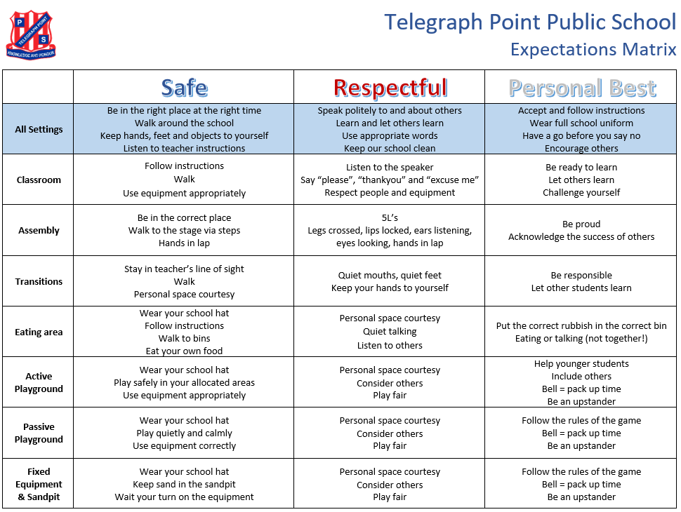
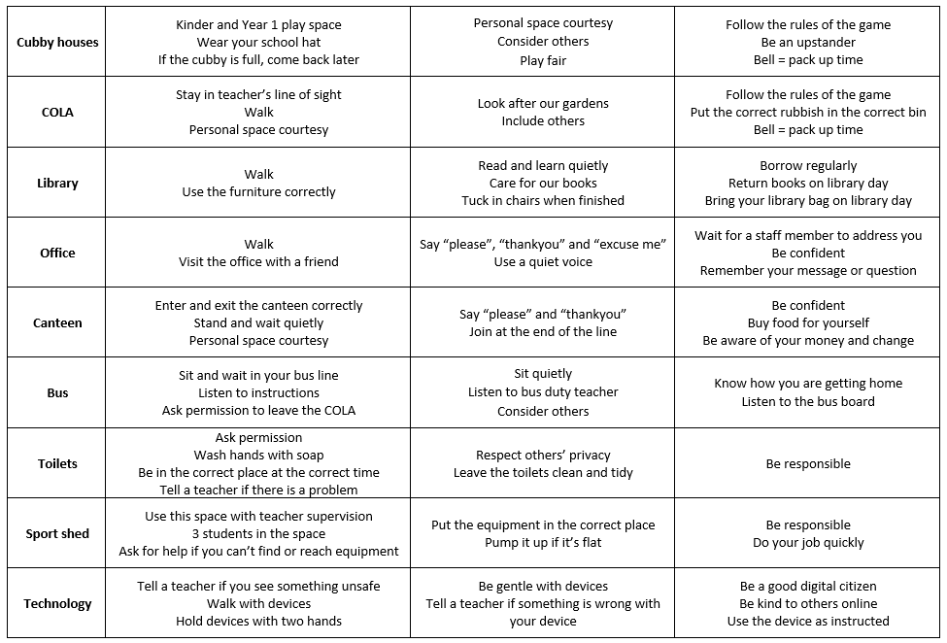

PBL team
The PBL committee meets on a regular basis to discuss playground/classroom needs and concerns, behaviour management, rewards and issues arising. Regular tracking of incidents and behaviour concerns in undertaken during these meetings and information is used to guide and inform decisions, lessons and future directions regarding student wellbeing.
Acknowledgement systems
Spottos
Spottos are awarded to students for demonstrating school expectations. Teachers identify the expectation the student is receiving the Spotto for and discuss this with the student before awarded a “safe” (blue), “respectful” (red), or “personal best” (white) spotto token.
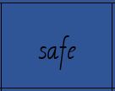
Spottos are distributed in both learning environments and play environments. Each classroom has a clear perspex box to collect the spotto tokens. When the box is full, the class enjoys their agreed classroom reward. Similarly, there is a larger perspex box for playground spotto tokens. When the box is full, the whole school enjoys their agreed school reward. Class and school rewards could be an ice block, extra play time, mufti day, fun activity etc.
This collaborative approach to rewards fosters attitudes of cooperation and team work as students work as part of their class and school group to earn rewards that can be enjoyed together.
Merit awards
Four merit awards per class are handed out at each fortnightly assembly. These are to describe a behaviour that aligns with the school’s expectations of safe, respectful and personal best, as well as one teacher choice merit. Students may also receive a merit awarded by the Parliamentarian student leaders.
Postcards from the Principal
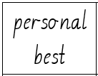
One student from each class is acknowledged for academic commitment and/or positive social attitude at school with a postcard from the Principal. These are delivered by mail at the end of each term.
Morning tea/Lunch with the Principal
One student from each class is acknowledged for demonstrated the school’s expectations of safe (Term 1), respectful (Term 2) and personal best (Term 3) with a special morning tea with the Principal.

Bronze, Silver, Gold and Platinum awards
Each term students who have had no major incidents (one negative incident in the ‘major’ category or three negative incidents in the same ‘minor’ category) or no more than 3 minor incidents recorded (see section on Student Behaviour and Discipline) receive a special certificate. Students progress through levels of Bronze, Silver, Gold and Platinum cumulatively. If a student misses out on a Bronze award in Term 1, they will have the opportunity to receive the Bronze award in subsequent terms throughout the year. Teacher discretion may be applied when awarding Bronze, Silver, Gold or Platinum certificates.
Uniform award
Each morning at our brief daily assembly Parliamentarians record the students in full school uniform. The class with the most students in uniform for the fortnight received the Uniform Award to display in their classroom for two weeks.
Attendance
Students with ≥90% attendance receive an attendance certificate each term. Students with ≥90% attendance for the year receive an annual attendance certificate at the end of Term 4.
Presentation Day awards
Kindergarten award
All Kindergarten students will receive a high quality picture book and certificate for their successful first year of school.
Academic Excellence
One student from each class is selected to receive this award. Recipients are chosen for academic excellence. In the case of composite classes, one student from each year group (across multiple classes) is selected for this award. E.g. In the case of one cohort being split over two classes (Year 5 being split into a 4/5 and 5/6 class) only one student in that cohort will receive the Academic Excellence award. These prestigious awards will be handed out by the Principal.
Most Improved
One student is selected from each class (Years 1-6) for displaying improvement in English or Mathematics, or both. In the case of composite classes, one student from each year group within the class is selected for this award.
Citizenship
One student is selected from each class who demonstrates a commitment to our school community. This student consistently displays our school expectations of safe, respectful and personal best. In the case of composite classes, one student from the class is selected for this award.
Major Presentation Day awards (Stage 3)
DUX
The DUX award is awarded to a Year 6 student. They are selected only on academic merit. Academic results from English and Mathematics assessments are gathered throughout the year. These scores are then totalled the student who has achieved the highest overall result is deemed to be the DUX of the school.
Citizenship
One student from Stage 3 is selected as recipient for the Citizenship award. This award is given to a student who demonstrates leadership, models school expectations, influences peers in a positive manner, fosters love of the school, wears correct school uniform and participates in school events and activities.
Country Women’s Association (CWA) Scholarship
Two students from Year 6 are selected to receive a $200 scholarship provided to their prospective high school to cover student fees. This scholarship supports students and families in their successful transition to high school.
Port Macquarie-Hastings Council Citizenship Award
One student from Stage 3 is selected as recipient for this award. This award is given to a student who demonstrates leadership both within the school and broader community.
Sportsperson of the Year
Sportsperson of the Year is Telegraph Point Public School’s most prestigious sporting award. All PSSA sporting achievements and contributions throughout the year are tallied to identify the highest scoring sportsperson of the school.
Level of Representation | Carnival Attended (example only) | Points Awarded
Telegraph Point PS | Hastings/Camden Haven Zone | 0.5
Hastings/Camden Haven Zone | Lower North Coast | 1
Lower North Coast | North Coast | 2
North Coast | NSW State | 4
NSW State | National Championships | 8
Premier’s Sporting Award
The Premier’s Sporting Award acknowledges a student for their commitment to fair play, achievement in their sporting discipline, and overall contribution to their school’s weekly sporting program.

NSW Department of Education policies and resources:
- About Positive Behaviour for Learning
- NSW Department of Education Student Behaviour Strategy
- Behaviour Code for Students

Protecting Children and Young People (Child Protection)
At Telegraph Point Public School all educators, staff, students and volunteers are committed to identifying possible risk and significant risk of harm to children and young people. Our staff are subject to a set of roles and responsibilities on safety, supporting children and young people, as well as monitoring, evaluation and reporting requirements. We comprehend our duty of care responsibilities to protect children from all types of abuse, and adhere to our legislative obligations at all times. A full list of the legislation that governs us can be accessed at the end of this section.
The NSW Government recognises that care and protection for children and young people is a shared responsibility. It begins with parents, but when government support becomes necessary, it is not the sole responsibility of community services but a collective responsibility. Keep Them Safe: A shared approach to child wellbeing provides the framework for parents, communities, and government and non-government agencies to work together to support children and families.
Responsibilities
Principals
- ensure all staff have participated in an initial child protection induction and an update during the past year.
- ensure all staff are aware of the indicators of abuse and neglect of children and young people.
- ensure all staff are aware of their obligation to advise the principal or workplace manager of concerns about the safety, welfare and wellbeing of children and young people that arise during the course of their work.
- ensure that all staff are aware of their mandatory obligation to report suspected risk of significant harm and of the procedures for doing so.
Reporting
- use appropriate tools to inform decision making, such as the online Mandatory Reporter Guide, professional judgment or specialist advice, where there are concerns about risk of harm.
- determine whether concerns about the safety, welfare or wellbeing of children or young people constitute risk of significant harm and, if they do, report these to Family and Community Services.
- seek advice from the Child Wellbeing Unit where there is uncertainty about whether concerns amount to risk of significant harm.
- contact the Child Wellbeing Unit about the safety, welfare and wellbeing of children and young people where:
  - there are concerns about risk of harm, that do not meet the threshold of significant harm but are not trivial.
  - the Mandatory Reporter Guide indicates this should be done.
  - a case has been reported to Family and Community Services and did not meet the risk of significant harm threshold.
  - there is an observable pattern of cumulative harm that does not meet the threshold of significant harm.
Supporting children and young people
- establish effective systems in their workplace for:
  - child protection concerns to be identified in the course of the work of staff, reported and action taken, where appropriate, so vulnerable children and young people are supported.
  - reasonable steps to be taken to coordinate decision making and coordinate services to children and young people and their families with other local service providers, if required.
  - collaborative work with other agencies for the care and protection of children and young people in ways that strengthen and support the family and in a manner that respects the functions and expertise of each service provider.
- exchange relevant information to progress assessments, investigations and case management as permitted by law.
- use best endeavours in responding to a request for a service from Family and Community Services provided that the request is consistent with departmental responsibilities and policies.
All employees
Training
- participate in a child protection induction and in annual updates. This includes all staff – principals, workplace managers, teaching and non-teaching staff, part-time, temporary and casual staff and those who join during the year.
Reporting
- adhere to mandatory procedures for conveying risk of harm concerns to the principal or workplace manager.
- adhere to mandatory procedures for reporting risk of significant harm to Family and Community Services.
- ensure, where they have reported any risk of significant harm concerns to the principal or workplace manager, that the principal or workplace manager has reported those concerns to Family and Community Services.
- report directly to Family and Community Services if they believe the principal or workplace manager has not reported risk of significant harm concerns to Family and Community Services, and they still have concerns about risk of significant harm.
- ensure that any relevant information that they become aware of, subsequent to a report being made to Family and Community Services or following contact with the Child Wellbeing Unit, is provided to Family and Community Services or the Child Wellbeing Unit respectively. If the additional information forms concern about risk of significant harm a report must be made to Family and Community Services.
Supporting children and young people
- cooperate with reasonable steps to coordinate service delivery and decision- making with other relevant service providers.
- avoid undertaking any investigation of the circumstances giving rise to a report where risk of significant harm has been reported, without the express prior approval of the relevant Family and Community Services case officer.
- inform students, including apprentices or trainees, of their right to be protected from abuse and of avenues of support if they have concerns about abuse.
Monitoring, evaluation and reporting requirements
Principals and workplace managers must maintain a workplace register of staff participation in annual updates and of inductions of new staff, or they must sight individual records of staff inductions. This applies to all staff including non-teaching staff, part-time, temporary and casual staff.
A record is to be kept of reports to Family and Community Services as confirmation that mandatory reporting requirements have been met. The report reference number should be recorded.
The record and related papers are to be retained by principals or workplace managers in secure storage and kept confidential. These records are to be provided to any successor.
Where a reference numbers provided by the Child Wellbeing Unit must be recorded and kept.
If serious safety issues remain after a report has been made to, and accepted by, Family and Community Services, principals or workplace managers will refer the matter to the departmental regional officer responsible for student services so the case can be taken up at a senior level within Family and Community Services.
The Working with Children Check
The Working with Children Check is an important part of the NSW Department of Education's recruitment process to prevent people who pose a risk to the safety, welfare and wellbeing of children from being employed or engaged in child-related work.
The Working with Children Check applies to all people employed or engaged in child-related work in the NSW Department of Education, in any of the following capacities:
- as a paid employee;
- as a self-employed person or as a contractor or subcontractor;
- as a volunteer;
- as a person undertaking practical training as part of an educational or vocational course (other than as a student undertaking work experience);
- as a minister, priest, rabbi, mufti or other religious leader or spiritual officer of a religion or other member of a religious organisation
In addition to the WWCC requirements, workers who are engaged in child-related work as a paid employee of the department or as a contractor in the Assisted School Travel Program are required to meet the department’s National Criminal Records Check requirements to determine their suitability for employment or engagement.
NSW Department of Education policies and resources:
- Children and Young Persons (Care and Protection) Act 1998
- Education and Care Services National Regulations 2011
- Crimes Act 1990
- Privacy and Personal Information Protection Act 1998
- Health Records and Information Privacy Act 2002
- Commission for Children and Young People Act 1998
- Ombudsman Act 1974
- Education Act 1990
- Child Protection Policy: Responding to and reporting students at risk of harm
- Child Protection Policy Guidelines: Responding to a reporting students at risk of harm
- Mandatory Reporter Guide
- Child Protection: Allegations Against Employees Policy
- Student Welfare Policy
- Working With Children Check Policy

Student Behaviour and Discipline
Telegraph Point Public School is committed to a positive approach to student discipline in our school. Practices that foster engagement in learning, set clear limits, recognise appropriate behaviour and apply consequences for inappropriate and/or violent behaviour are more likely to promote positive student behaviour than punishment alone.
As a Positive Behaviour for Learning (PBL) school, we practice a schoolwide, consistent approach to guiding student behaviour. Student behaviour will be discussed between the student, classroom teacher, supervisor and parents. In cases of ongoing concern, behaviour programs may be established or further disciplinary action taken.
Classroom
All classroom teachers follow the same procedure when a school expectation has not been followed. This procedure involves:
- Indirect strategies (non-verbal cue and praising students following expectations)
- Direct strategies (verbal warning and opportunity to reteach)
- Visual cue (changing a chart, using a colour system)
- Timeout with parent contact (opportunity for students to change their behaviour)
- Buddy class timeout with parent contact (removal from the challenging environment)
- Loss of privilege (make up learning during a break, miss out on a fun activity)
Incident forms are used as a recordkeeping tool outlining details of an incident where a school expectation has not been followed. These incident forms allow staff to monitor ongoing challenging behaviour and plan for successful student participation in the classroom. In the situation where a student has three of the same minor incident forms recorded in one term, the student will attend a reflection session with Executive staff and may miss out on a classroom reward.
Playground
All classroom teachers follow the same procedure when a school expectation has not been followed. This procedure involves:
- Indirect strategies (non-verbal cue and proximity)
- Direct strategies (verbal warning)
- Playground timeout with parent contact
Incident forms allow staff to monitor ongoing challenging behaviour and plan for successful student participation in the playground. In the situation where a student has three of the same minor incident forms recorded in one term, the student will attend a reflection session with Executive staff and may miss out on a whole school reward.

Behaviour management flowchart
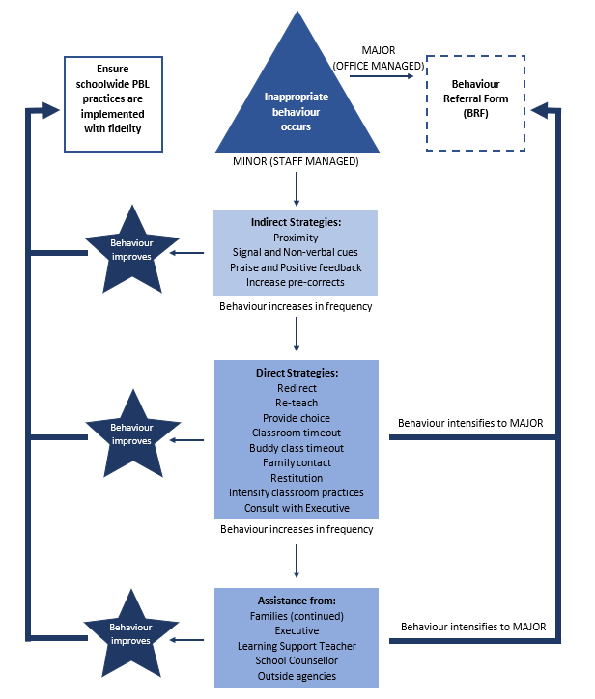

Strategies for guiding student behaviour
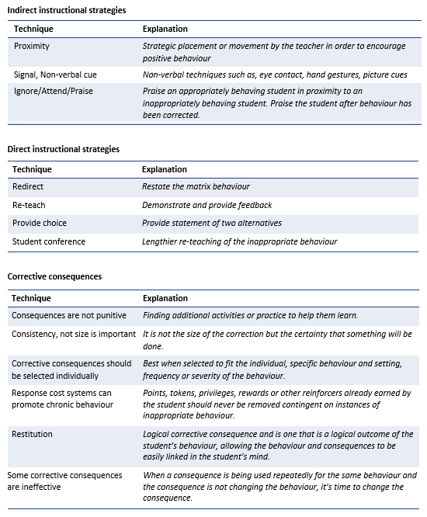

Behaviour consistency chart
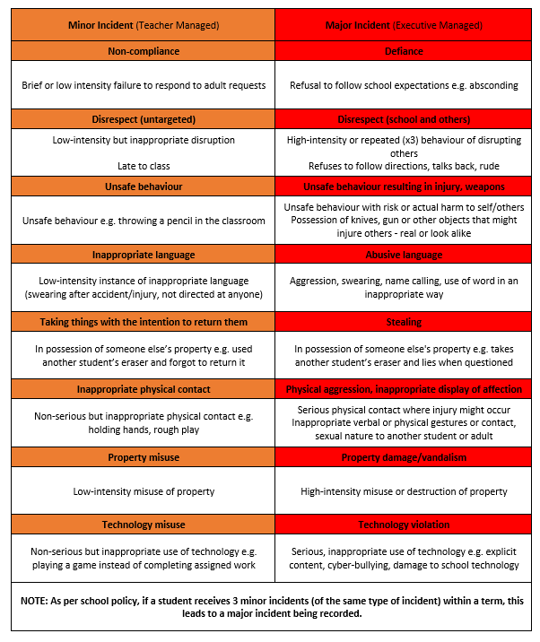
NSW Department of Education policies and resources:
- NSW Department of Education Behaviour Code for Students
- Suspension and Expulsion of School Students Procedures
- Guidelines for the use of Timeout Strategies Including Dedicated Timeout Rooms
- Student Discipline in Government Schools Policy
- A New Student Behaviour Strategy

Supporting EAL/D Students
Students with English as an Additional Language/Dialect (EAL/D) come from a diverse range of backgrounds. They enter Australian schools with varying levels of proficiency in Standard Australian English (SAE). As a result, Government uses student enrolment data to allocate extra funding to schools to support their learning needs.
An integral part of our school plan is student support. EAL/D support programs are designed to cater to the learning needs of EAL/D students in order for them to gain full access to the Australian Curriculum. Programs focus on language learning through explicit teaching of the structure, linguistic features and sociolinguistic and sociocultural aspects of SAE. Regular review of programs, professional development and resources is ongoing.
NSW Department of Education policies and resources:
- Multicultural Education Policy
- English as an Additional Language or Dialect: Advice for Schools
- Aboriginal Education and Training Policy
- Roads to Refuge
- Anti-Discrimination Act 1977
- Multicultural NSW Act 2000

Supporting Refugee Students
Resettlement support is critical in enabling refugees to overcome the impacts of trauma and adjust to life in Australia. All schools with refugee students have a responsibility to ensure that appropriate support is provided to meet their educational and welfare needs.
NSW Department of Education policies and resources:
- Multicultural Education Policy
- English as an Additional Language or Dialect: Advice for Schools
- Aboriginal Education and Training Policy
- Roads to Refuge
- Anti-Discrimination Act 1977
- Multicultural NSW Act 2000

Supporting Students with a Disability
In all schools there will be students who experience varying difficulties with learning. Learning difficulties may arise at any time throughout a student’s school life. Students may experience difficulties in learning because of the ways in which they learn or the rates at which they learn. The primary responsibly for meeting the learning and support needs of students with disability lies with the school and classroom teacher. The Learning and Support Team plays a key role in coordinating and planning support for students with disability and additional learning needs.
Responsibilities
Principals
- ensure implementation of support for students experiencing difficulties in learning
- plan to include the use of Learning and Support resources to improve outcomes for students experiencing difficulties in learning
- participate in the annual Nationally Consistent Collection of Data on School Students with Disability (NCCD)
Teachers
- ensure that students who experience difficulties in learning are assisted according to the policy statement and key principles underpinning support
Support staff
- ensure that students who experience difficulties in learning are assisted according to the policy statement and key principles underpinning support
NSW Department of Education policies and resources:
- People with Disabilities: Statement of Commitment
- Assisting Students with Learning Difficulties Policy
- Nationally Consistent Collection of Data
- NSW Public Schools – Disability, learning and support

Drug Education
Drug education should begin before children and young people are likely to face situations when they make decisions about drug use and before behavioural patterns have become established. Age appropriate drug education forms a part of the mandatory Personal Development, Health and Physical Education (PDHPE) K-10 curriculum.
Telegraph Point Public School implements drug education teaching as detailed in the NSW PDHPE K-10 syllabus, which provides evidence-based guidance for age appropriate content.
Drug Education in NSW Government Schools
Stage based content within NSW PDHPE K-10 syllabus allows teachers flexibility to deliver content at a time that meets the student needs, based on maturity, local context and learning progression.
Kindergarten to Year 2
Students learn:
- about medicines and the need to use them properly under the supervision of an adult
- that medicines and poisons must be stored out of reach of children
- how to contact emergency services if there is an accident at home.
Years 3 to 6
Students learn:
- about legal and illegal drugs, how they affect the body and how they can be helpful and harmful
- the effects of tobacco on the body and ways to avoid passive smoking
- about the effects of alcohol on the body.
NSW Department of Education policies and resources:
- Drugs in Schools Policy
- Curriculum Support – PDHPE K-10
- NSW Public Schools – Drug Education

Learning Support Team
The Learning and Support Team (LaST) is a team of dedicated professionals who initiate whole school planning and support mechanisms for students and teachers alike. It has been formed with the purpose of addressing the cognitive, emotional, social, physical and spiritual wellbeing of students through the coordination, development, implementation, monitoring and evaluation of educational programs. The LaST team meet regularly to identify, document and monitor student progress and achievement. Each term a review is conducted to ensure students are making expected gains, and additional support is identified where necessary.
The prime function of the LaST is to ensure that the needs of all students are met using a three-tiered model of support: Tier 1 – Universal (80%), Tier 2 – Targeted (15%) and Tier 3 – Intensive (5%).
Responsibilities
Classroom Teacher
- holds primary responsibility for the learning of every student in the class
Learning and support team
- supports teachers in identifying and responding to additional learning needs of students
- facilitates and coordinates a whole school approach to improving the learning outcomes of every student
- coordinates planning processes and resourcing for students with disability and additional learning and support needs
- designs and implements the supports required to build teacher capacity so that all students access quality learning
- develops collaborative partnerships with the school, parents and carers, other professionals and the wider school community.
Every school has a learning and support team. The composition of teams may vary as they are made up of members according to the needs of the school and community in which they work.
Learning and support teacher
- provides direct and timely specialist assistance to students in mainstream classes with disability and additional learning and support needs
- Provides direct and timely specialist assistance to the teachers of students with disability and additional learning and support needs.
Their work emphasises:
- the needs of individual students
- school priorities, and
- evidence-based programs to assist students with additional learning and support needs.
Learning and support teachers use a collaborative and consultative approach so that students themselves and their parents and carers are actively involved in decision-making.
NSW Department of Education policies and resources:
- People with Disabilities: Statement of Commitment
- Assisting Students with Learning Difficulties Policy
- Nationally Consistent Collection of Data
- NSW Public Schools – Disability, learning and support

Nutrition
All schools should promote healthy eating and good nutrition. School canteens are required to implement the NSW Healthy School Canteen Strategy that includes food and drink criteria. Telegraph Point Public School aims to promote and model healthy eating and good nutrition programs and activities. Classroom teaching of nutrition education is part of the Personal Development, Health and Physical Education (PDHPE) key learning area and is mandatory for all students from Kindergarten to Year 10. Teaching and learning and class activities in other key learning areas reinforce healthy eating and good nutrition wherever possible.
Telegraph Point Public School proudly implements the Crunch&Sip program which aims to increase the quantities of vegetables, fruits and water being consumed by our students. Crunch&Sip provides time during the school day for students to eat vegetables and fruit and drink water in the classroom. Students bring vegetables and/or fruit and a water bottle to school each day for the Crunch&Sip break.
Telegraph Point Public School is also a Live Life Well school. Live Life Well is a joint initiative between the Department of Education and the Ministry of Health and aims to get students more active more often, and to develop healthy eating habits.
NSW Department of Education policies and resources:
- Nutrition in Schools Policy
- Australian Dietary Guidelines
- NSW Healthy School Canteens Menu Check Service
- Anaphylaxis Procedures for Schools
- NSW Healthy School Canteen Strategy – Food and Drink Criteria
- Live Life Well @ School
- NSW Public Schools – School Canteens

Road Safety Education
Schools contribute to students' knowledge, skills and understanding of being a road user who is personally and socially responsible. Telegraph Point Public School promotes road safety through teaching and learning programs and taking measures to protect students against injury or harm on roads while at school.
Effective road safety education programs are taught in each stage of learning (K-6) as part of the Personal Development, Health and Physical Education (PDHPE) syllabus. Students have the opportunity to participate in National Walk to School Day and National Ride to School Day.
NSW Department of Education policies and resources:
- Road Safety Education, Driver Education and Training Policy
- NSW Government Schools Road Safety Education
- Transport NSW Centre for Road Safety

Student Health
Telegraph Point Public School is dedicated to assisting students who have health support needs at school. Processes and systems are in place to adequately collect health information about students upon enrolment and on a regular basis to protect the health and safety of students.
An individual health care plan is created for any student with severe asthma, type 1 diabetes, epilepsy or anaphylaxis and/or diagnosed at risk of an emergency and/or requiring the administration of health care procedures. Health care plans are reviewed annually.
Where requested, staff can assist with the administration of prescribed medication for a student when a medical practitioner has prescribed medication that must be administered during the school day.
In the instance of communicable health concerns such as head lice and chicken pox, parents/caregivers are made aware through written communication.
Although we cannot guarantee to be nut-free, all visitors to the school are asked to refrain from bringing nut products to the school. This does not include items that are labelled as “may contain traces of nuts”.
Responsibilities
Principals
- implement policy and procedures to ensure that systems are in place to protect the health and safety of all students when they are at school or involved in school activities
- develop and document local procedures to support student health. These need to reflect department policy and incorporate local needs, including:
  - first aid
  - temporary care of students who become unwell at schools
  - administering prescribed medications and health care procedures
  - individual health care plans
  - immunisation documentation requirements
  - supply and storage of medication
  - provision of emergency care
School staff
- take reasonable measures to protect students against risk of injury or harm that should reasonably have been foreseen
- take reasonable care for the health and safety of all persons in the workplace and ensure the health and safety of all in the workplace, including assisting in an emergency
- provide assistance, where staff do not have first aid qualifications, to ensure that a student receives medical attention including first aid
Particular school staff
- it is the responsibility of the staff members who volunteer and are trained in administering prescribed medications to do so in accordance with Department policy and procedures
- it is the responsibility of the staff members who volunteer and are trained to perform health care procedures to do so in accordance with Department policy and procedures
- it is the responsibility of all the school staff members who volunteer and are trained in administering first aid to do so in accordance with Department policy and procedures
Parents
- cooperate with the school on student health matters
- inform the school of their child’s health needs at enrolment or when health conditions develop or change and complete a consent form (provided by the front office)
- liaise with the child's medical practitioner about the implications of any health condition for their schooling, and convey this advice and information to the school
- if required, provide prescribed medication and 'consumables' for the school to administer in a timely way and as agreed with the Principal
- where relevant, collaborate with the school to support the child's health needs at school, including updating information and reviewing health care plans. Relevant information on the parents’ role can be found on the student health section of the Department's website
Students
- contribute to the provision of a healthy and safe school environment
- ensure that medication is taken for the purpose for which it is intended by the person for whom it is intended
- cooperate with staff in managing their health
- as relevant to the individual, develop the understandings and skills needed to progressively manage their own health.
Monitoring and review
The NSW Work Health and Safety Act 2011 requires the school to report certain work-related incidents within given timeframes. Depending on the type of incident, the school may need to notify WorkCover. Incidents and injuries are reported in accordance with the Incident Reporting Policy.
Principals will ensure that individual health care plans are reviewed at least annually.
NSW Department of Education policies and resources:
- Student Health in NSW Public Schools: A summary and consolidation of policy
- Student Welfare policy
- Work Health and Safety (WHS) policy
- NSW Public Schools – Anaphylaxis Procedures for Schools
- NSW Public Schools – Individual Health Care Planning
- NSW Anti-Discrimination Act 1977
- Commonwealth Disability Discrimination Act 1992
- NSW Work Health and Safety Act 2011
- NSW Privacy and Personal Information Protection Act 1998
- Health Records and Information Privacy Act 2002

Sun Safety
Schools have a responsibility to provide a safe environment for students, including providing adequate protection from the sun.
The Student Health policy requires schools to implement practices related to student health that comply with the NSW Work Health and Safety Act 2011 (WHS Act) and that demonstrate a commitment to collaboration with parents to support the wellbeing of students.
The school community implements a range of strategies to promote sun safety which may include:
- staff are encouraged to model sun safety behaviours
- sun safety is promoted as a health and safety issue rather than as a matter of discipline. Therefore age appropriate sun safe strategies such as ‘No hat, stay in the shade’ are implemented
- shade is available for students at recess and lunch and in areas for outdoor teaching
- the school curriculum includes teaching students about the need for sun safety across year levels
- hats are part of the school uniform and are a way to promote sun safety practices
- sunscreen roll-ons may be provided from home for students to use
- alternative arrangements may be made as a result of sun conditions; including closing all or part of the playground in extreme weather or scheduling outdoor activities in the shade or at times outside of peak ultraviolet radiation times where possible
NSW Department of Education policies and resources:
- Sun safety for Students Guidelines
- School Uniform Policy
- Student Health in NSW Public Schools: A summary and consolidation of policy
- Sport Safety Guidelines
- NSW Public Schools – Sun Safety
- Cancer Council SunSmart in Schools

Transition to Kindergarten
Telegraph Point Public School is committed to supporting students in a smooth transition into Kindergarten, as children who have a positive start to school are likely to engage and experience ongoing academic and social success.
Workshops and information sessions are conducted throughout the year to support parents to equip children as they transition to school. There are several components aimed to assist in preparing children for the commencement of school including a transition program in Term 4 from 9.30-11.30am for one week and social stories.
The orientation days welcome children starting Kindergarten the following year by providing them with the opportunity to go to a kindergarten classroom and experience what it is like in an authentic school classroom. There is also a parent information session, which details for parents how they can support their child during the transition process.
NSW Department of Education policies and resources:
- The Wellbeing Framework for Schools
- Schools Excellence Framework

Transition to High School
The transition to high school is an exciting time for students and their families. It is the beginning of a whole new chapter; meeting new people and experiencing a range of different subjects and sports. It can also be an anxious and stressful time in both preparing for the move to high school and in managing the first few weeks. Telegraph Point Public School is committed to supporting students to have a smooth transition into high school through a number of programs.
Year 6 transition program for all students
The transition to high school program provides support to students and their families. This commences with an information session early in the year to support parents in the process of applying for a high school placement for their child. High schools will also offer information nights to provide parents with information regarding Year 7 at that particular high school and may offer a tour of the facility.
Many high schools have an orientation day giving students a taste of high school life which often includes a tour around the school, information about the high school and experience in various subject classes. Students at Telegraph Point Public School will have the opportunity to visit Hastings Secondary College as part of a transition program.
Enhanced Transition Programs
Some children require additional support and may be included in a small group program with Hastings Secondary College. The activities will focus on the needs of the groups and may include assistance with reducing worries about moving to high school, further developing organisational skills, and role-playing and other activities around building positive relationships.
Individual Programs
Some students require tailored programs and are provided additional experience with transition in the high school settings. This is negotiated between each school and the family to determine how to best meet the individual needs of the students.
NSW Department of Education policies and resources:
- The Wellbeing Framework for Schools
- Schools Excellence Framework

Student use of digital devices and online services
This policy guides student use of digital devices and online services at our school. Telegraph Point Public School acknowledges the educational value of digital devices and online services in supporting and enhancing educational outcomes and student wellbeing. We also recognise they may cause harm if used inappropriately and that we need to support our students to use them in a safe, respectful manner.
The use of digital devices by primary school students (personal or school provided) must be restricted during class, recess and lunch unless an exception is approved by the teacher or the principal. Students at Telegraph Point Public School are restricted from using their own digital devices (this includes mobile phone and smart watches) before and after school whilst on school grounds and throughout the day. If a mobile phone is required for the reasons of safety for travelling to and from school, students and parents/carers must follow our school policy. No digital devices (this includes mobile phones and smart watches) are to be taken on excursions or camps.
Students using school-owned devices are expected to use digital devices and online services in safe and respectful ways. Students are supported to understand and follow school rules and procedures that will ensure everyone behaves safely, respectfully and responsibly with peers, school staff and the school community as described in the Telegraph Point Public School Student Wellbeing and Engagement policy.

Exemptions
Exemptions to any part of this policy may apply for some students in some circumstances. Parents and carers can request an exemption and these will be considered on a case-by-case basis and granted when required by law or at the principal's discretion.
Consequence for inappropriate use of digital devices and/or online services
- The student is reminded of school policy and expectations, following minor or major behaviour procedures.
- The student is given a warning from a teacher or other staff member.
- The student’s digital device may be confiscated by a staff member. Confiscated devices are handed in to the school office and can be collected at the end of the day.
- The student is referred to the Assistant Principal or Principal, and contact is made with the student’s parent or carer.
- The student’s access to the school network is restricted through the EMU tool on the DoE portal.
- The teacher of principal arranges a meeting with the student’s parent or carer.
- Additional consequences may occur based on our Student Behaviour and Discipline policy and Positive Behaviour for Learning (PBL) policy.
Contact between students parents/carers during the school day
It has always been the school’s practice to pass on important message to students throughout the day. This can be done by phoning or emailing the school office and requesting that a message be given to the child. No digital devices (this includes mobile phones and smart watches) are to be used by students on school grounds for contacting parents and carers. No digital devices (this includes mobile phones and smart watches) are to be taken on excursions or camps. Parents will be kept informed of excursion details through Sentral Parent Portal, email and/or text messages. During school hours, parents and carers are expected to only contact their children via the school office. In the case of an emergency, contact is made through the school office during school hours and if students are on an excursion, students may be contacted through the venue and the relevant phone numbers will be provided to parents prior to the excursion.
Responsibilities
Classroom teachers
- Deliver learning experiences that encourage safe and respectful use of digital devices and online services. This includes:
  - Establishing agreed classroom expectations for using digital devices and online services, in line with this policy and departmental policy.
  - Identifying strategies to ensure that all students are able to engage in classroom activities including strategies to accommodate students without a digital device.
  - Reading and abiding by the Terms of Service for any online services they use in teaching, including those limiting use by age.
  - Educating students about online privacy, intellectual property, copyright, digital literacy, and other online safety related issues.
- Model appropriate use of digital devices and online services in line with departmental policy.
- Respond to and report any breaches and incidents of inappropriate use of digital devices and online services as required by school policies, departmental policy and any statutory and regulatory requirements. This includes:
  - Reporting the creation, possession or distribution of indecent or offensive material to the Incident Support and Report hotline as required by the Incident Notification and Response Procedures, and consider any mandatory reporting requirements.
  - Working with the department and the Office of the eSafety Commissioner (if necessary) to resolve cases of serious online bullying and image-based abuse.
  - Following the school’s behaviour management procedures when responding to any incident of inappropriate student behaviour relating to the use of digital devices of online services.
- If feasible and particularly as issues emerge, support parents and carers to understand strategies that promote their children’s safe and respectful use of digital devices and online services.
- Participate in professional development related to appropriate use of digital devices and online services.
Parents
- Recognise the role they play in educating their children and modelling the behaviours that underpin the safe and respectful use of digital devices and online services.
- Support implementation of the school policy, including its approach to resolving issues.
- Take responsibility for their child’s use of digital devices and online services at home such as the use of online services with age and content restrictions.
- Communicate with school staff and the school community respectfully and collaboratively as outlined in the School Community Charter.
- Switch off or put their digital devices on silent when at official school functions, during meetings and when assisting in the classroom.
Students
- Be safe and respectful users of digital devices and online services, and support their peers to be the same.
- Respect and follow school rules and procedures and the decisions made by staff, knowing that other schools may have different arrangements.
- Communicate respectfully and collaboratively with peers, school staff and the school community and behave in the ways described in the Behaviour Code for Students.
- Report incidents of inappropriate use of digital devices and online services.
NSW Department of Education policies and resources:
- Student use of digital devices and online services policy
- Incident notification and response procedures
- School community charter

Appendix 1: Safe, Respectful and Personal Best – Digital Devices and Online Services
SAFE
- Protect your personal information, including your name, address, school, email address, telephone number, pictures of you and other personal details.
- Only use your own usernames and passwords, and never share them with others.
- Ask a teacher or other responsible adult for help if anyone online asks for your personal information, wants to meet you or offers you money or gifts.
- Let a teacher or other responsible adult know immediately if you find anything online that is suspicious, harmful, in appropriate or makes you uncomfortable.
- Never hack, disable or bypass any hardware or software security, including any virus protection, spam and filter settings
RESPECTFUL
- Respect and protect the privacy, safety and wellbeing of others.
- Do not share anyone else’s personal information.
- Get permission before you take a photo or video of someone, including from the person and from a teacher.
- Do not harass or bully other students, school staff or anyone, this includes cyberbullying using a digital device or online service.
- Do not send or share messages or content that could cause harm, including things that might be:
  - inappropriate, offensive or abusive;
  - upsetting or embarrassing to another person or group;
  - considered bullying;
  - private or confidential; and/or
  - a virus or other harmful software.
PERSONAL BEST
- Follow all school rules and instructions from school staff, including when using digital devices and online services.
- Take care with school-owned digital devices you share with others, so that other people can use them after you.
- Use online services in responsible and age-appropriate ways.
  - Only use online services in the ways agreed to with your teacher.
  - Only access appropriate content and websites, including when using the school’s filtered network and personal, unfiltered networks.
  - Do not use online services to buy or sell things online, to gamble or to do anything that breaks the law.
- Understand that everything done on the school’s network is monitored and can be used in investigations, court proceedings or for other legal reasons.
- Report incidents of inappropriate use of digital devices and online services.
Appendix 2: Mobile phone code of practice
I agree to abide by the Telegraph Point Public School Student Use of Digital Devices and Online Services Policy.
I agree to abide by the following rules when I bring my mobile phone to school:
I will not turn my phone on whilst on school grounds and any phone calls that need to be made are to be made through the Office. If anyone needs to make contact during the school day they are to phone the Office and leave a message.
I understand that the following rules apply:
- I will not give out the personal details of another person.
- I will not give out phone numbers without the permission of the person or people concerned.
- I will not send SMS/picture/video/voice messages or make phone calls.
- I will not take photos or videos of others or myself whilst in school uniform.
- I will report to a parent or guardian any SMS/picture/video messages or phone calls that are unpleasant or make me feel uncomfortable in any way.
- I understand that the use of smart watches is strictly prohibited at school.
- I understand that breaches of the mobile phone code of practice may result in me being prohibited from bringing my phone to school.
- I will hand my phone to the office at the beginning of the day and collect at the end of each day.
- I cannot use their phone at any time whilst on school grounds.
--------------------------------------------------------------------------------------------------------------------------
Student/Parent Mobile Phone Usage Agreement
I agree to abide by the School’s mobile phone code of practice.
I understand that if I breach any of these rules I may lose the right to bring a mobile phone to school.
Student name: ________________________________________ Class: _______________
Mobile Phone Number: __________________________________
Student signature: _________________________________ Date: _______________
Parent name: __________________________________________
Parent Signature: _________________________________ Date: _______________
Office Use Only
Date received: Authorised:

